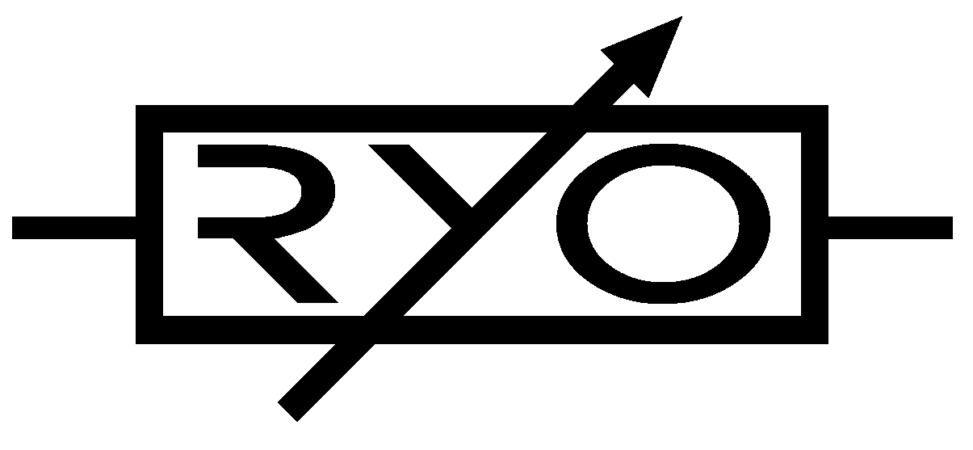
LjunggrenAudio RYO Optodist:
an OptoVCA with distortion and LED limiting.

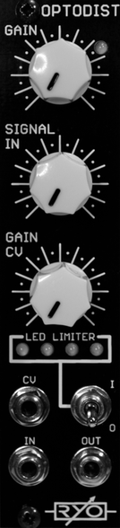

Quickstart – what is the Optodist and how do I get going?

The Optodist is a compact, easy to use, easy to build and great sounding distortion module which will also work as a VCA if desired. Consisting of a voltage controlled amplifier based on a pair of Silonex/Advanced Photonix optocouplers that allow a characterful overdriven sound and plucky dynamic response to CV, it is as equally at home “crisping up” highs and mids or warming up your lows as it is at turning a resonant filter into a howling beast or your drums into crushing carnage.

Installation

To begin installation, please make sure that:
- you have a standard pinout eurorack bus board
- you have +12V and -12V power rails on that bus board [no +5V supply is required]
- the power rails are not overloaded

!!!Before installing this module disconnect the power from your system!!!

- Double check the polarity of the ribbon cable - The red stripe should be aligned with the -12V rail, on both the module and on the bus board

[we use shrouded headers but it's still possible a cable has been assembled with the stripe on the wrong side of the shroud so always double check!].

Also make sure when using busboards without shrouded headers that the pins aren't transposed a row vertically or horizontally – all pins should insert into holes on the cable.

Although we use both PTC fuses and schottky diodes to provide reverse polarity and excess current protection, we do not take any responsibility for damages
caused by wrong power supply connection!

After you have connected everything, double checked it and ensured your case is closed such that no power lines can be touched by your hand or any stray cables drop into holes, turn on your system and test the module

We designed the Optodist using SR3 optocouplers; the SR3's give a tighter, snappier CV response and have less bleed through of the signal when gain is fully off and signal in is set to low settings for a somewhat clean signal or lighter distortion effect.
Please note that due to the nature of the vactrol-style optocouplers, response behaviour may vary between different factory batches.]
Also on board is an LED limiter circuit which soft-clips the signal through a set of 4 LEDs (visible on the front panel), for adding a different flavour to your distortion. the choice of LEDs is up to you, experimenting with different types will affect the sound.
Two colours of LEDs were used and tested in development of the Optodist, green being standard but also some investigations into yellow were made that revealed that it has a subtly brighter tone and is much brighter visually as well. Any 3mm LEDs from infra red up to piercing bright white or violet will work, although there may need to be an adjustment to a resistor value to get the correct brightness.

The Optodist is a novice-friendly project, it is a low part count, single-PCB build that only requires the most basic experience in PCB soldering and module assembly:

The amplifier has an exponential response to control voltages; and accepts between 0V and 8V cv by default. The amplifier accepts both DC and AC signals, though it should be noted that due to the slew rate of the optocouplers, audio rate modulation of the gain CV is limited in frequency to a degree dictated by the choice of either SR2 or SR3 optocouplers.

The module has one audio input and one audio output; the signal in knob dictating the audio input level. The VCA has a control voltage input with attenuator (gain CV), and manual gain control which sets either the VCA initial open level and/or the amount of overdrive gain.

The module can be used as a basic attenuator; by disconnecting cv/keeping gain cv fully CCW, and adjusting the signal in and gain control as desired.

When the cv input is presented with a control voltage between 0V and 8V, in this setup, the module will behave as a traditional relatively clean sounding VCA; albeit with some character and limitations as dictated by the optocouplers.

Depending on your calibration settings and choice of optocouplers, opening either the 'signal in' knob and/or opening the 'gain' knob past approximately 50% will introduce distortion; this distortion will vary in character depending on the settings, but can be tamed by engaging the LED clipping circuit, although this will further alter the character of the distortion.

(when gain is between fully off [CCW] and 50% the module can be used as an attenuator or as a relatively clean VCA where gain dictates the VCA initial level; opening the 'gain' knob past approximately 50% will introduce distortion - from 50% up to max gain (full cw) the Optodist will boost the signal with increasing distortion).

Dimensions
Height: 3U [128.5mm],
Width: 6HP [30mm],
Depth: 31mm (with power cable attached)

Weight: ???g

Current consumption
+12V rail min 13mA to max 16mA
-12V rail min 13mA to max 16mA
+5V rail no +5V supply required

[There are small power variations between different vactrol and LED varieties. The option requiring least power is SR3 optocoupler paired with green limiter LEDs.]

Basic specifications
total frequency controllable range dc to 50 kHz
max input/output audio signal 20 Vpp
CV input range (calibrate to preference) 0V to +10V max

Max gain 0dB gain with +8V @ cv input
(calibrated as VCA) -40dB gain with 0V @ cv input

Nominal impedances
Audio signal input: 100k ohm
Audio Signal output: 1k ohm
CV input: 100k ohm

Patch ideas:

Although uses of VCAs in patch examples and ideas are found readily online and in some books, and similarly those familiar with using distortion effects perhaps from the guitar pedal cultural background, there are many other less obvious ways to use the optodist in patches in your modular rig:

below i've include everything from some inspiring words to links and embedded videos and diagrams with popular modules used to perform necessary duties showing the patches that have been used in the videos; and, as ever, experiment – RYO modules are designed with all necessary protection and fail-safes so you can just start plugging in patch cables and see what happens!

ping it;
many modules with vactrols in the CV-path can be 'pinged' – excited by a short spike of CV such as a trigger or by a few ms pulse of noise, the vactrols will ring with a very natural, organic sounding, woody decay – great for drums or percussive tonal instruments.

distort a cv signal;
try something different - such as distorting an FM modulator wave so that the resulting sound output from a carrier VCO/VCF/VCA is wildly different.

Thicken up a 'pad' type sound;
for rich, full crunchiness and texture DivKid used the Optodist in his first of a series of 'Patch ideas' videos:

>>Patch Idea #1 - Heavy Wavetables
>>30 May 2014
>>[In the video he uses the RYO Optodist to crunch up and distort
wavetables from a Mutable Instruments Braids:]

https://www.youtube.com/watch?v=LZ_vG0la2FI

Audio Routing: CV Routing:

Braids out to Optodist in uLFO sine out to Cold Mac Slope in
Optodist out to filter in. Cold Mac 'rectified out' Stackabled*
Filter lowpass out to output To: Optodist CV in and Braids Timbre' in'[green input]

*(multiples [mults] and other forms of signal splitters can be used.)
